Pupils who access ASL support at school
Ideas for parents on how to continue to support their child at home
Try to make learning as fun as possible. Have a clear daily routine and give brain breaks. These are a few suggestions you are not required to complete every task. HFW Words (High Frequency words can be found online – Fry’s or Dolch) These are words that children can find tricky but will come across frequently. Learning to read and write them would support their learning in all literacy tasks. When learning the words make it as active as possible, there are ideas below.
Daily Reading is important, please continue to read with your child daily.
Teach your monster to read    www.teachyourmonstertoread.com  A great free and fun resource that can be used on the computer or as an app. It develops reading skills and is a great resource to help motivate pupils who find reading tricky. There are 3 levels starting from initial sounds developing onto phonemes and theN reading. | BBC Dance Matt Typing  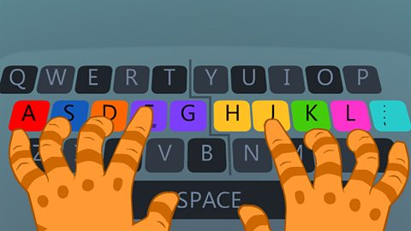  http://play.bbc.co.uk/play/pen/ghdxbnvx7h  A typing skills programme that helps pupils use the correct fingers and encourages touch typing. | Nessy    A great computer-based programme that can help dyslexic pupils. It can also be purchased as an app. Some pupils have access to this programme at school.
www.doorwayonline.org.uk  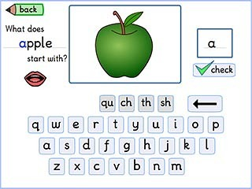  A great online free resource that supports literacy, numeracy, money, time, typing skills and memory.  Sumdog or Education city is an app that many schools use to support Literacy / Numeracy. Check for log in details. | Active Literacy Activities for HFW  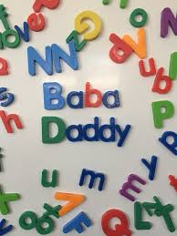  Write he words with chalk outside  Pass a ball and spell the word  Write the words in sand / paint  Write the words on the shower screen  Type the spelling words up  Make up a mnemonic to help remember the tricky words  Make the words with playdough  Write the words on someone’s back | Active Literacy Activities  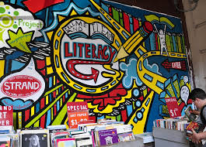  Play knots and crosses with tricky words  Learn the alphabet – plastic letters  Write out words in fancy writing  Draw pictures to go with words  Write the words on the carpet  Make the words with plastic letters  Make words with pasta  Write out the words with different colours

