Joining a Virtual Parent Council meeting without a Teams account

Mobile Instructions
You can join a Teams meeting anytime, from any device, whether or not you have a Teams account. If you don't have an account, follow these steps to join as a guest.
1.Go to the meeting invite and select Join Microsoft Teams Meeting.
2.If you don't already have the Teams mobile app, you'll be taken to your app store to download it.
3.Download the app and open it right from the app store page.
4. Teams will ask if it's okay to use your mic. Be sure to allow it so others in the meeting will be able to hear you.
5.Next, you'll be given two options for joining your meeting: Join as a guest or Sign in and join. Choose Join as a guest.
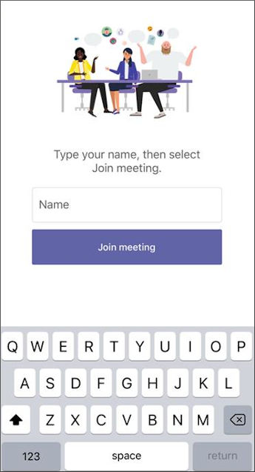
6.Type your name and tap Join meeting.
7.Once you're in the meeting turn your video on and your mic off by tapping on the centre of your screen to show the meeting controls. Tap again to hide them.

Meeting Controls are as follows
A B C D E F G H

A – Camera which can be turned on and off by clicking on the icon
B- Microphone which can be turned on and off by clicking on the icon
C- Open share tray – possibly not needed but can be used to share desktop or documents
D - More options. This is where the recording facility can be found and where you can share meeting notes
E – Raise your hand
F – Chat bar. Click on this and you can type a comment
G – Show participants in the meeting
H – to hang up

